**Missing Ranges**

Question

You are given an inclusive range [lower, upper] and a **sorted unique** integer array nums, where all elements are in the inclusive range.

A number x is considered **missing** if x is in the range [lower, upper] and x is not in nums.

Return *the****smallest sorted****list of ranges that****cover every missing number exactly***. That is, no element of nums is in any of the ranges, and each missing number is in one of the ranges.

Each range [a,b] in the list should be output as:

* "a->b" if a != b
* "a" if a == b

**Example 1:**

**Input:** nums = [0,1,3,50,75], lower = 0, upper = 99

**Output:** ["2","4->49","51->74","76->99"]

**Explanation:** The ranges are:

[2,2] --> "2"

[4,49] --> "4->49"

[51,74] --> "51->74"

[76,99] --> "76->99"

**Example 2:**

**Input:** nums = [], lower = 1, upper = 1

**Output:** ["1"]

**Explanation:** The only missing range is [1,1], which becomes "1".

**Example 3:**

**Input:** nums = [], lower = -3, upper = -1

**Output:** ["-3->-1"]

**Explanation:** The only missing range is [-3,-1], which becomes "-3->-1".

**Example 4:**

**Input:** nums = [-1], lower = -1, upper = -1

**Output:** []

**Explanation:** There are no missing ranges since there are no missing numbers.

**Example 5:**

**Input:** nums = [-1], lower = -2, upper = -1

**Output:** ["-2"]

**Constraints:**

* -109 <= lower <= upper <= 109
* 0 <= nums.length <= 100
* lower <= nums[i] <= upper
* All the values of nums are **unique**.

# **Solution**

#### **Approach 1: Linear Scan**

**Intuition and Algorithm**

Since the input array, nums, is sorted ascendingly and all the elements in it are within the given [lower, upper] bounds, we can simply check consecutive elements to see if they differ by one or not. If they don't, then we have found a missing range.

* When nums[i] - nums[i-1] == 1, we know that there are no missing elements between nums[i-1] and nums[i].
* When nums[i] - nums[i-1] > 1, we know that [nums[i-1] + 1, nums[i] - 1] range of elements are missing.

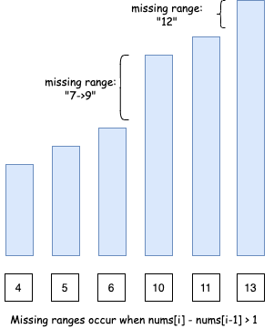

However, there are two edge cases:

* Case 1: If we don't start with lower as the first element of the array, we will need to consider [lower, num[0] - 1] missing range as well.

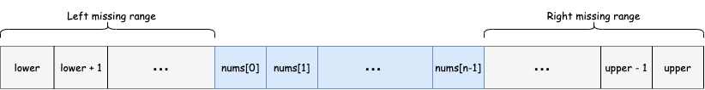

* Case 2: Similarly, if we don't end with upper as the last element of the array, we will need to consider [nums[n-1] + 1, upper] missing range as well. Note n here is the length of the input array nums.

Coding Solution

Java

|  |
| --- |
| class Solution {  public List<String> findMissingRanges(int[] nums, int lower, int upper) {  int n = nums.length;  if (n == 0) {  return Collections.singletonList(formatRange(lower, upper));  }  List<String> missingRanges = new ArrayList<>();  // Edge case 1) Missing ranges at the beginning  if (nums[0] > lower) {  missingRanges.add(formatRange(lower, nums[0] - 1));  }  // Missing ranges between array elements  for (int i = 1; i < n; ++i) {  if (nums[i] - nums[i - 1] > 1) {  missingRanges.add(formatRange(nums[i - 1] + 1, nums[i] - 1));  }  }  // Edge case 2) Missing ranges at the end  if (nums[n - 1] < upper) {  missingRanges.add(formatRange(nums[n - 1] + 1, upper));  }  return missingRanges;  }  // formats range in the requested format  String formatRange(int lower, int upper) {  if (lower == upper) {  return String.valueOf(lower);  } else {  return lower + "->" + upper;  }  }  } |

C++

|  |
| --- |
| class Solution {  public:  vector<string> findMissingRanges(vector<int>& nums, int lower, int upper) {  int n = nums.size();  vector<string> missingRanges;  if (n == 0) {  missingRanges.push_back(formatRange(lower, upper));  return missingRanges;  }  // Edge case 1) Missing ranges at the beginning  if (nums[0] > lower) {  missingRanges.push_back(formatRange(lower, nums[0] - 1));  }  // Missing ranges between array elements  for (int i = 1; i < n; ++i) {  if (nums[i] - nums[i - 1] > 1) {  missingRanges.push_back(formatRange(nums[i - 1] + 1, nums[i] - 1));  }  }  // Edge case 2) Missing ranges at the end  if (nums[n - 1] < upper) {  missingRanges.push_back(formatRange(nums[n - 1] + 1, upper));  }  return missingRanges;  }  // formats range in the requested format  string formatRange(int lower, int upper) {  if (lower == upper) {  return to_string(lower);  } else {  return to_string(lower) + "->" + to_string(upper);  }  }  }; |

**Complexity Analysis**

* Time complexity : O(N)*O*(*N*), where N*N* is the length of the input array. This is because we are only iterating over the array once.
* Space complexity : O(N)*O*(*N*) if we take the output into account and O(1)*O*(1) otherwise, where N*N* is the length of the input array. This is because we could have a missing range between each of the consecutive element of the input array. Hence, our output list that we need to return will be of size N*N*.